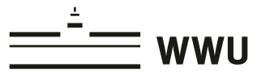
Join our MA-Colloquium
Does my research question make sense?
Is my topic okay for an MA-thesis?

Which formal aspects do I have to keep in mind?

Can I present my arguments in a clear manner?

image: pixabay.com
Are you writing your MA-Thesis in English language education at the moment, or are you thinking about doing so in the near future?
If so, the ELE team of the WWU Münster would like to invite you to join our new
MA-Colloquium. The colloquium is open for all MA-students and aims at offering you:
- an opportunity to present your work in progress to your fellow students and lecturers
- individualised feedback on your work in progress
- an opportunity to connect and exchange ideas with other MA-thesis candidates
- general input on how to write your MA-thesis
In the winter term 2020/21, the MA-Colloquium will take place via Zoom on the following dates:
- November 3rd 2020 (6-7.30pm; kick-off meeting: planning the presentations)
- November 17th 2020 (6-7.30pm; input and presentations)
- December 8th 2020 (6-7.30pm; input and presentations)
- February 2nd 2021 (6-7.30pm; input and presentations)
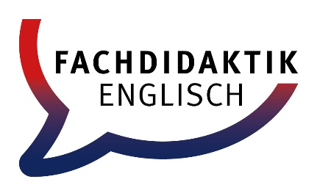
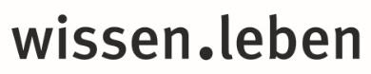
If you want to participate or have any questions, please contact:
Daniel Becker (daniel.becker@uni-muenster.de)

