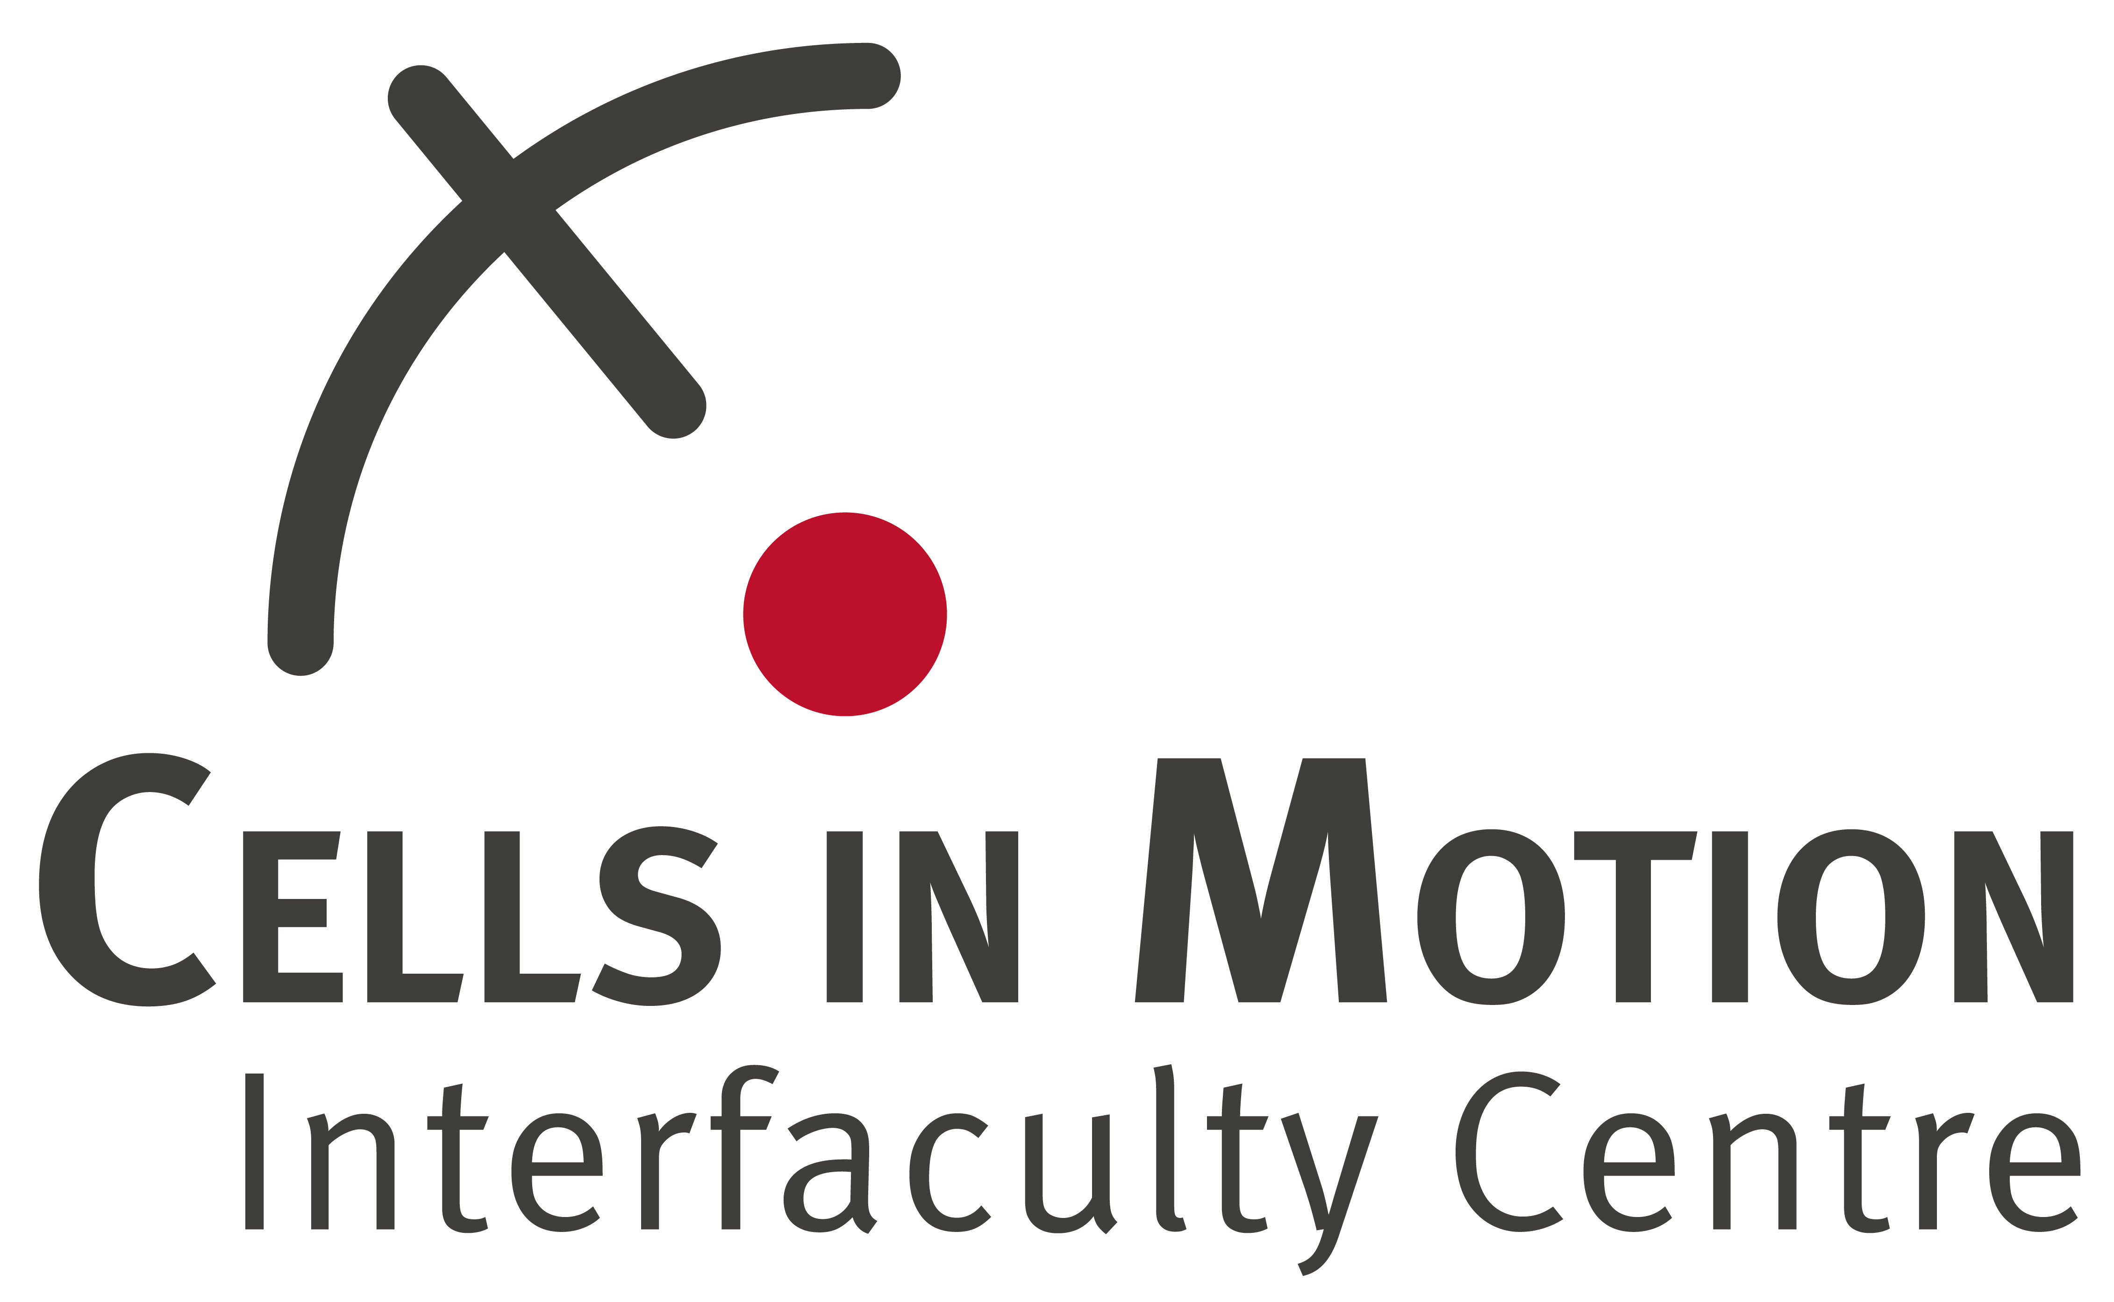
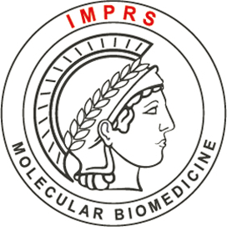

Joint PhD program of the University of Münster and the
Max Planck Institute for Molecular Biomedicine

Reference request form

Dear referee,
We would be grateful if you could provide us with an evaluation of the applicant's academic and general suitability for postgraduate studies.
Please upload the completed form at the website given in our recent e-mail which was forwarded to you by the applicant. In order to do this you will need the applicant’s registration code which you can also find in our e-mail.
Thank you in advance for assisting in the evaluation of the applicant.
Sincerely yours,
Prof. Dr. Martin K. Wild

(Please use word processor to fill in the form)

Name of applicant
Name of referee
Referee’s institution

Since when and in which function do you know the applicant?

Please rate the applicant in comparison to other students with equivalent training
 | Best in class | Top  5% | Top  10% | Top  20% | Top  50% | next  50% | Cannot  assess
Theoretical knowledge
Technical proficiency
Ability to work independently
Ability to work in a team
Motivation
Intellectual abilities
Ability to express oneself
Academic achievements
Creativity
Flexibility
Overall recommendation

Short letter of recommendation: Please give your impression of the applicant and comment specifically on strengths and limitiatons for postgraduate studies.

What do you consider to be the applicant’s strengths or talents?

What could the applicant still improve in the future?

Date |  | Name (no signature required)

