To evaluate the two candidate definitions and methods for calculating vessel wall thickness, we created a test set (n = 62) by selecting images (Supplementary Figure 4) meeting the following inclusion criteria: (1) the image contained only one single vessel, (2) segmentation output showed uninterrupted circumferential labeling of the vessel wall, and (3) segmentation output does not show false-positive satellite lumens and only contains one accurately segmented lumen. A senior neuropathologist (WY) manually measured the vessel wall thickness for each image using ImageJ.²⁹ For these manual measurements, blood vessel wall thickness was defined as the distance between the inner boundary of the vessel endothelium and the outer boundary of the tunica adventitia along a line perpendicular to the wall’s “backbone” or minimum skeleton – the arc equidistant from the outer and inner wall boundaries, which equates to the sum of the widths of the endothelium, tunica intima, tunica media, and tunica adventitia.³⁷ The neuropathologist was asked to complete four vessel wall thickness measurements per image (Supplementary Figure 5).

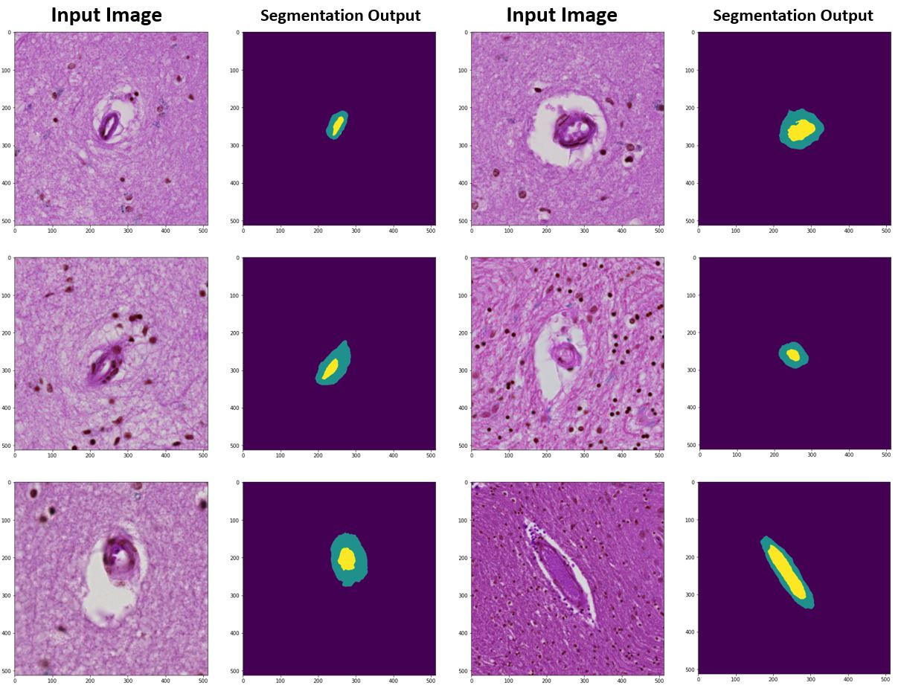
Supplementary Figure 4: Example input image and segmentation output pairs in test set used to evaluate the two candidate definitions of vessel wall thickness. The inclusion criteria for each image were: (1) the image contained only one single vessel, (2) segmentation output showed uninterrupted circumferential labeling of the vessel wall, and (3) segmentation output does not show false-positive satellite lumens and only contains one accurately segmented lumen. The test set included 62 total image and segmentation output pairs.

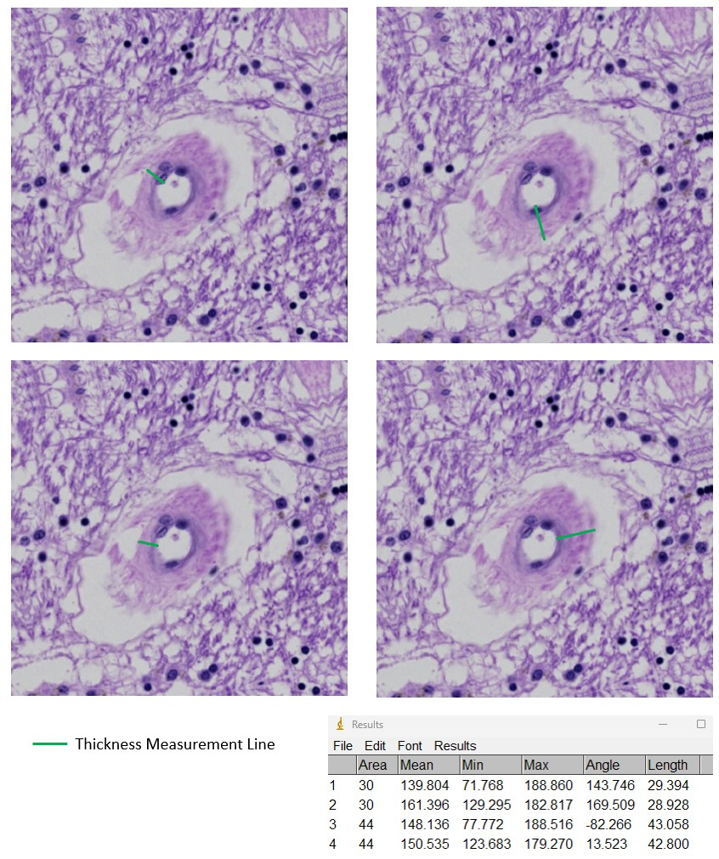
Supplementary Figure 5: Example manual vessel wall thickness measurements for one image within the SITE test set. Four manual measurements were made per image by a neuropathologist (WY). The test set contained 62 total images and segmentation outputs.

