**Arteriolosclerosis Annotation Protocol**

Create subfolder in each ID_XXX: ID_XXX_Masks, ID_XXX_Negative, ID_XXX_Positive ( create ID_XXX_Maybe, ID_XXX_Repeats, and ID_XXX_CannotAnnotate if needed)

Subfolder definition

* Masks: put the annotated masks here (instructions in the next section)
* Negative: not arteriolosclerosis
* Positive: arteriolosclerosis and able to annotate
* Maybe: not sure whether it’s positive/negative
* Repeats: put repeated tiles here without determining if they’re positive/negative
* CannotAnnotate: possible arteriolosclerosis but not able to annotate because of too small magnification or incomplete view of the vessel 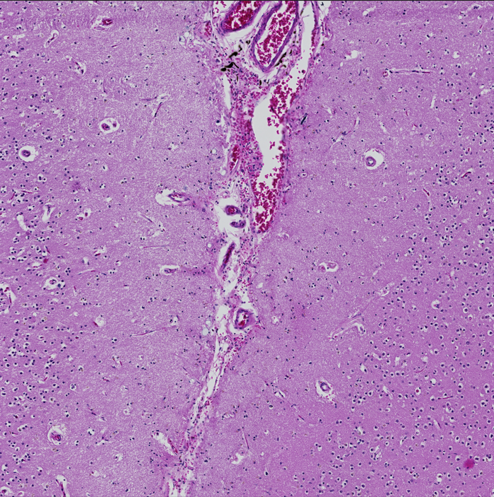

**Positive arteriolosclerosis**

* Cross-section rather than longitudinal
* Need to see the lumen clearly (or it’s hard to train the computer model)
* Need to be in white matter only, not in gray matter or leptomeninges

|  |  |  |  |
| --- | --- | --- | --- |
|  | Thickening of the media | Decreased lumen size | Loss of smooth muscle cells |
| None |  |  |  |
| Mild | ✔ |  |  |
| Moderate | ✔ | ✔ | ✔ |
| Severe | ✔ | ✔ | ✔ (complete loss) |

Reference:

[Vascular cognitive impairment neuropathology guidelines (VCING): the contribution of cerebrovascular pathology to cognitive impairment](https://academic.oup.com/brain/article/139/11/2957/2422120?login=true) (Skrobot et al, 2016)

graphs from [Brain Arteriolosclerosis](https://www.ncbi.nlm.nih.gov/pmc/articles/PMC8503820/) (Blevins et al, 2021)

**How to annotate**

1. Open Image J (Fiji) 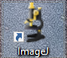
2. Copy the file name of the positive tile > drag the file to Image J window (or import via File > Open)
3. Double click the oval shape brush > check “Enable selection brush” > normally set 50 pixels for vessel border and 25 pixels for lumen border (can adjust based on different tiles)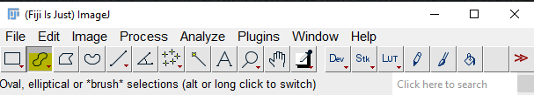 Graphical user interface, application

   Description automatically generated
4. Draw the vessel border by holding left click 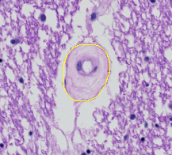
   1. If 2 positive vessels: shift and hold left click to draw
   2. To erase: draw from outside to trim the border
5. Click Edit > Selection > Create MaskGraphical user interface, application, email

   Description automatically generated
6. You should get the vessel area as white and the background as black as below. If not, click Edit > Invert (or Ctrl+Shift+I) A picture containing icon

   Description automatically generated
7. Save the mask by clicking File > Save As > PNGGraphical user interface, application

   Description automatically generated
8. Paste the file name that you copied in Step 2 in front of the Mask.png (make sure to save the masks in the subfolder ID_XXX_Masks) Graphical user interface, application

   Description automatically generated
9. Close the mask window and go back to annotate the lumen border A picture containing purple, vegetable, close

   Description automatically generated
10. Create a mask the same as Step 5-7
11. Paste the file name that you copied in Step 2 and put L before Mask.png to indicate the lumen mask Graphical user interface, application

    Description automatically generated
12. Repeat the steps above for the next tile