Abstract template and instructions for OPON 2018

First A. Author ¹, Second B. Author ^{1,2}, and Third C. Author ²
¹ Institution1, Address1, City1, Country1
² Institution2, Address2, City2, Country2

Please use this document as a template when preparing your abstract for OPON 2018 in Word. The abstract can contain any elements, e.g. figures, but please note that it will probably be printed black-and-white. It is essential to keep the margins of 25 mm on all sides, preferably use the standard 12 pt font, and to keep the length within one page. Please do not generate page numbers. We recommend formatting references as below [1,2]. In general, we would appreciate if the layout and formatting of this template is followed.
Please submit the abstract converted to the PDF format by email: opon2018@wwu.de.

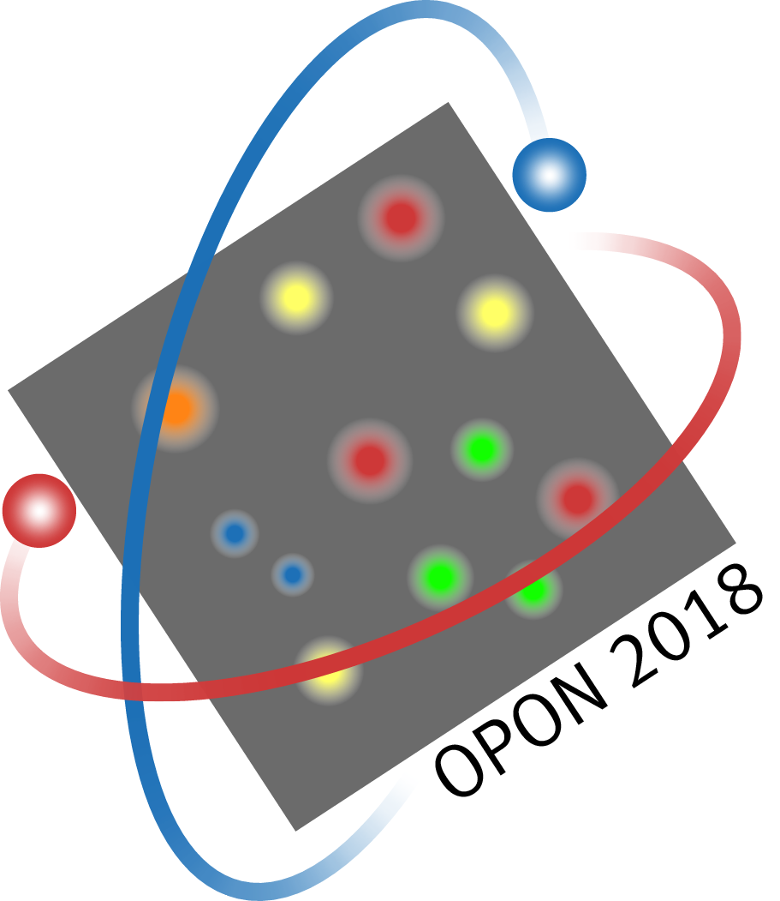

[1] L. J. Lander, and T. R. Parkin, Bull. Amer. Math. Soc. 72, 1079 (1966).
[2] D. Upper, J. Appl. Behav. Anal. 7, 497 (1974).

