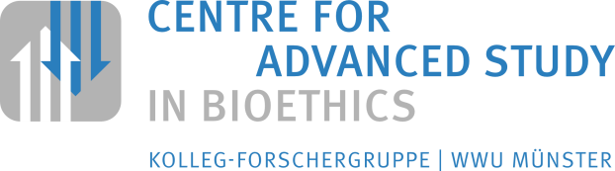
„Consent: Its Nature and Normative Relevance”
International Conference
21 – 23 June 2017
Bezirksregierung Münster
Freiherr-von-Vincke-Haus / Freiherr-von-Vincke-Saal
Domplatz 36

Registration
f m | Title | First Name | Family Name
Institution / University

Postal Address |  |  | E-Mail
 |  |  | Phone
I intend to participate in the conference  Wednesday 21st June 2017: whole day / morning / afternoon  Thursday 22nd June 2017: whole day / morning / afternoon  Friday 23rd October 2017: morning |  |  | I would like to have lunch  21st October 2017  22nd October 2017
My interest in the conference:

Remarks (e.g. also with regard to food intolerances etc.):

Date, Signature [resp. printed name]

