 | 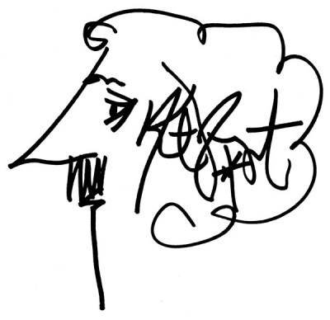

INVITATION – KURT VONNEGUT WORKSHOP –FEBRUARY 11, 2014

Kurt Vonnegut, known in particular for his satirical novel Slaughterhouse Five (1969), is one of the most significant American authors of the 20th century. Moreover, he has a special connection to the city of Muenster: the Vonnegut family (spelled “Fonnegut” before their immigration in the USA) originally stems from Muenster. Vonnegut’s great-grandfather Clemens Vonnegut was born in Muenster and immigrated in 1848, at the age of 24, to Indianapolis, where Kurt Vonnegut Jr. was born in 1922. In light of this connection, the Department of American Studies at the WWU Muenster is especially pleased to cordially invite you to a workshop on “Teaching Vonnegut.”

The workshop will take place in the context of a visit from professors and students of Ball State University (Muncie, Indiana). The delegation will present results of an Immersive Learning course of 12 students at Ball State University conducted in cooperation with the Kurt Vonnegut Memorial Library (Indianapolis). Their tasks encompassed the digitalization of Vonnegut manuscripts, the creation of a film archive, and also the planning and realization of a traveling exhibit, which will be shown in Dresden in February 2014.

With respect to this multi-faceted project, the workshop “Teaching Vonnegut” not only offers an introduction to the humorous and at the same time socially critical works of the author as teaching material for the (university-) classroom, but also a highly interesting glimpse at methods for teachers and students for productive interdisciplinary work and new approaches to literary subject matters.

For more information about the Immersive Learning project at Ball State University please see the following link:
http://cms.bsu.edu/news/articles/2012/8/immersive-learning-group-unveils-new-gifts-for-kurt-vonnegut-memorial-library

The workshop will take place on February 11, 2014, from 2:30 p.m. to 5:00 p.m. in the English Department of the WWU, Johannisstr. 12-20 (room to be announced). There is no participation fee; a written confirmation of participation can be issued upon request. Please register for the workshop under seksarkowsky@wwu.de by February 07, if you plan to attend.

